**Assignment-13**

* **Transformations and Actions**
* **Selecting, Renaming, Filtering Data in a Pandas DataFrame**

**Actions**

1. **collect()**

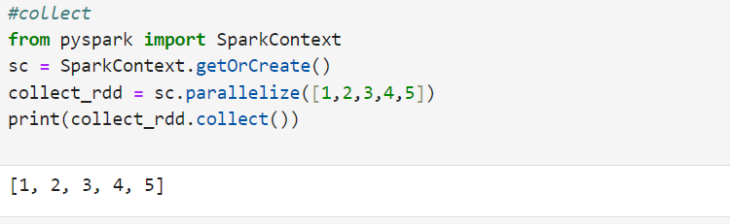

1. **count():**

1. **first():**

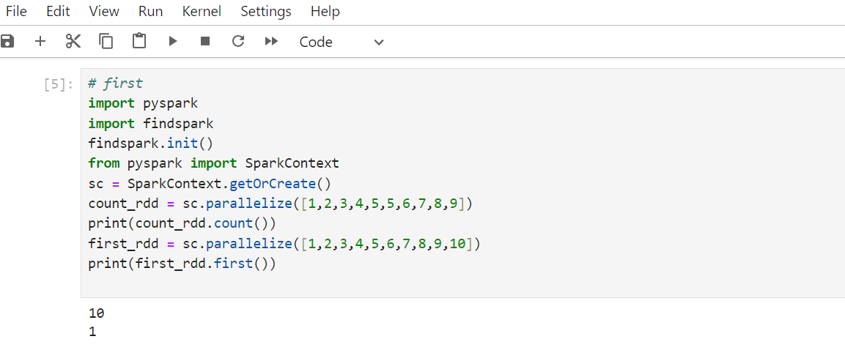

1. **take():**

1. **reduce():**

**Transformations**

1. **map():**

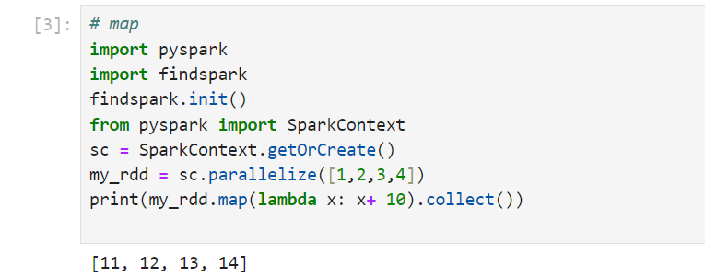

1. **filter():**

1. **union():**

1. **flatmap():**

**Transformations in Pair RDDs**

1. **reduceByKey():**

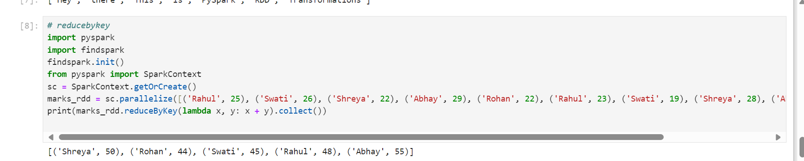

1. **sortByKey():**

1. **groupByKey():**

**Actions in Pair RDDs**

1. **countByKey():**

**Selecting, Renaming, Filtering Data in a Pandas DataFrame**

**Creating a DataFrame:**

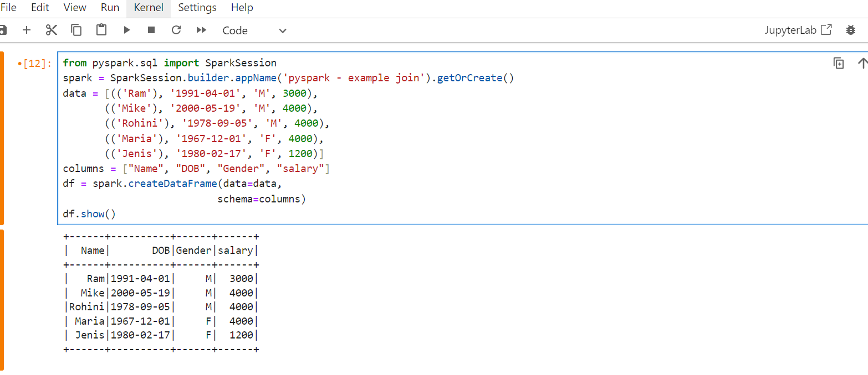

1. **Using withColumnRenamed()A white rectangular box with colorful text

   Description automatically generated**
2. **Using selectExpr():**

1. **Using select() method**

1. **Using toDF():**

